# Prime Factor

Contains LCM, GCD/HCF, CoPrime or relatively Prime

## Coprime/ Relatively Prime

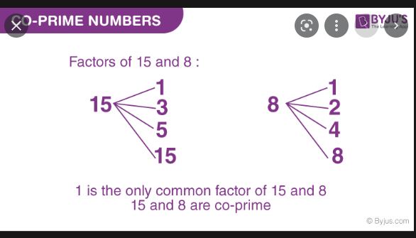

## Least Common Multiple

The smallest common positive integer which can be divisible by given two or more integers.

Multiples of 4: 4,8,12,16,20,24

Multiples of 6: 6,12,18,24

LCM(4,6): 12

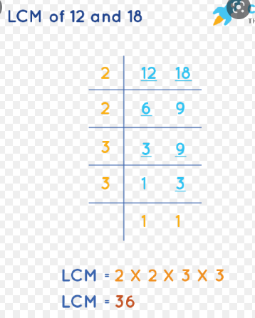

## Greatest Common Divisor/ Highest Common Factor

The greatest common factor which can divide given integers

Factors of 8: 2x2x2

Factors of 18: 2x3x3

GCD(8,18): 2

